User Manual

Accessing SpecterX Protected Files


About SpecterX
Enterprise Collaboration is vital for all business operations. It is key to reaching your business objectives, enabling remote work, and managing your partners, suppliers, customers, and even board communications.
However, as companies move towards cloud-based operations to enhance productivity, the control over their digital assets is diminishing, exposing sensitive data and intellectual property to potential security, privacy, and business risks. Regulatory requirements also mandate companies to keep a handle on their digital assets, but existing solutions often fall short.
SpecterX offers a solution. It keeps track of your data throughout its life cycle, irrespective of how many times it is shared or moved, both within or outside your organization. Our platform provides end-to-end visibility, full control, and comprehensive protection over data through a seamless user experience integrated with your existing tools. Our patented "Unified Driver" technology allows you to manage your data anywhere, with anyone, following your rules.

Receiving files through SpecterX
Files shared via SpecterX are secure and require authentication to gain access. When you open the email attachment or click on the ‘Open Attachments’ button, it will direct you to an access and authentication page.

Step 1: Open the email attachment
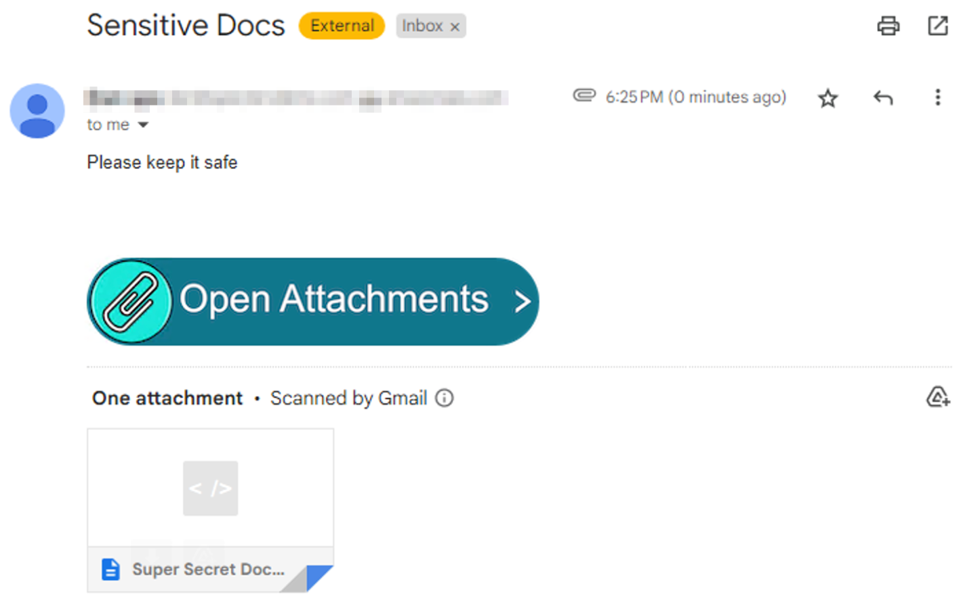
Click on the ‘Open Attachments’ button, you’ll be presented with several options to access the data.

Step 2: Choose how you want to access the file - either view online or download
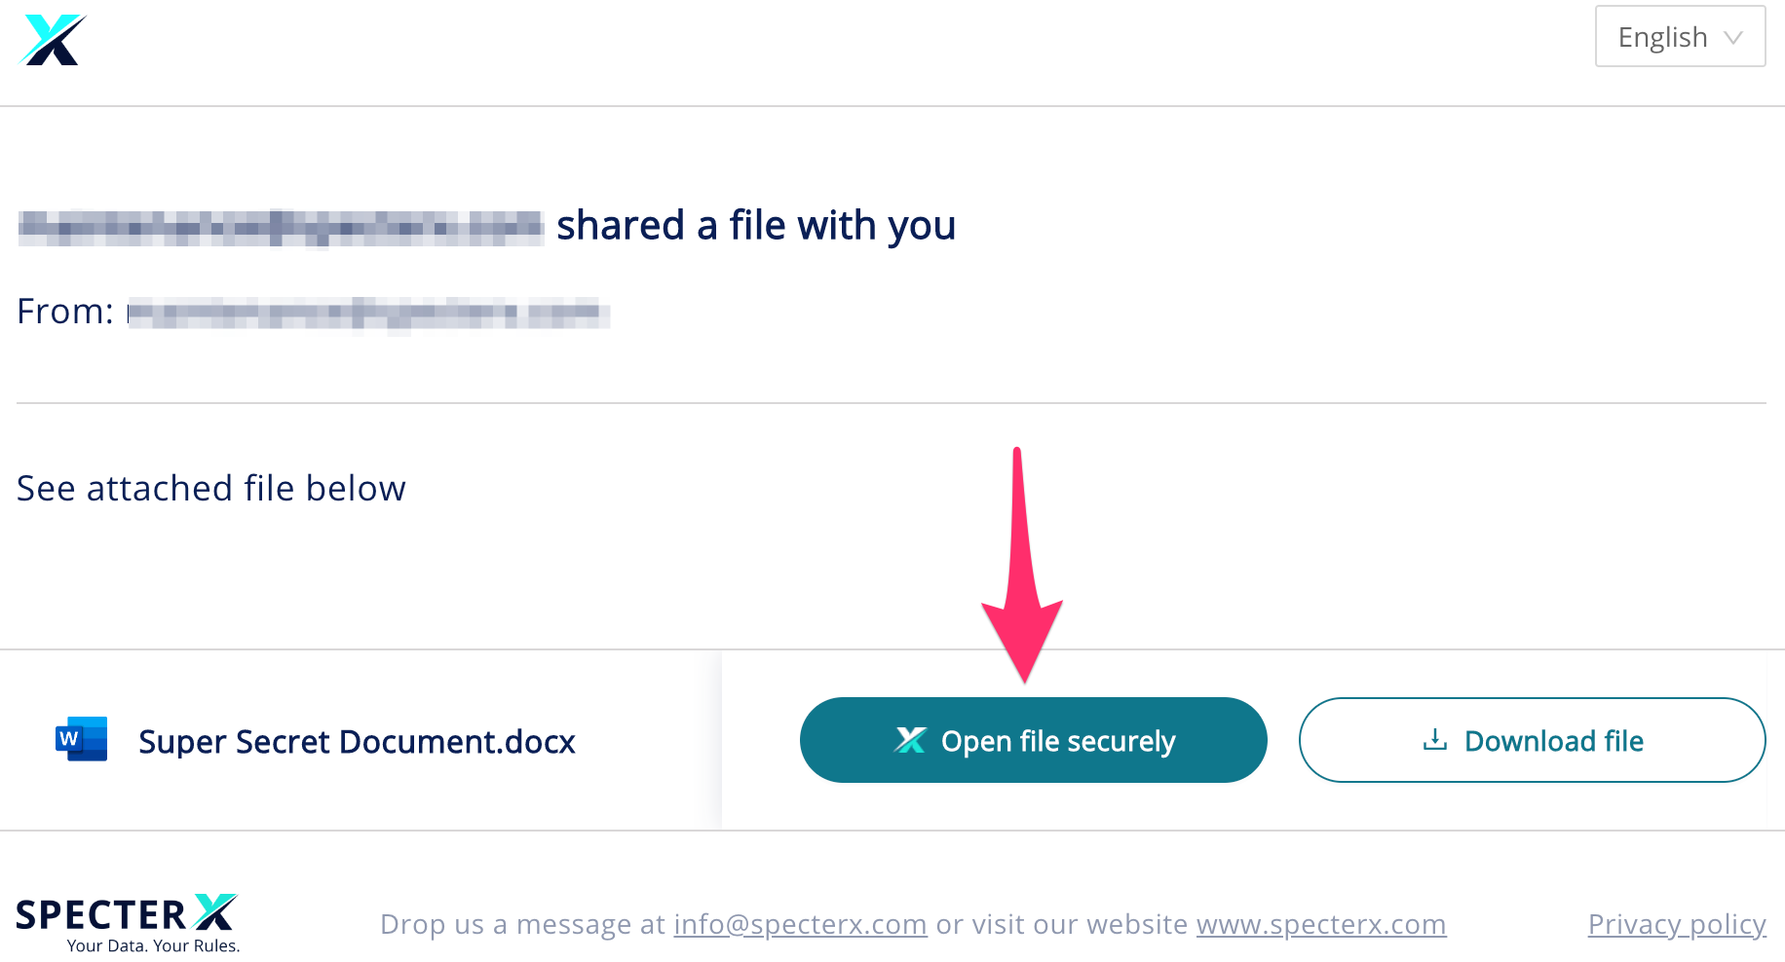

If this is your first time receiving files through SpecterX, the system will need to verify your identity. After choosing your preferred access option, you’ll get a one-time-code authentication via email or phone.

Step 3: Click ‘Send Code’
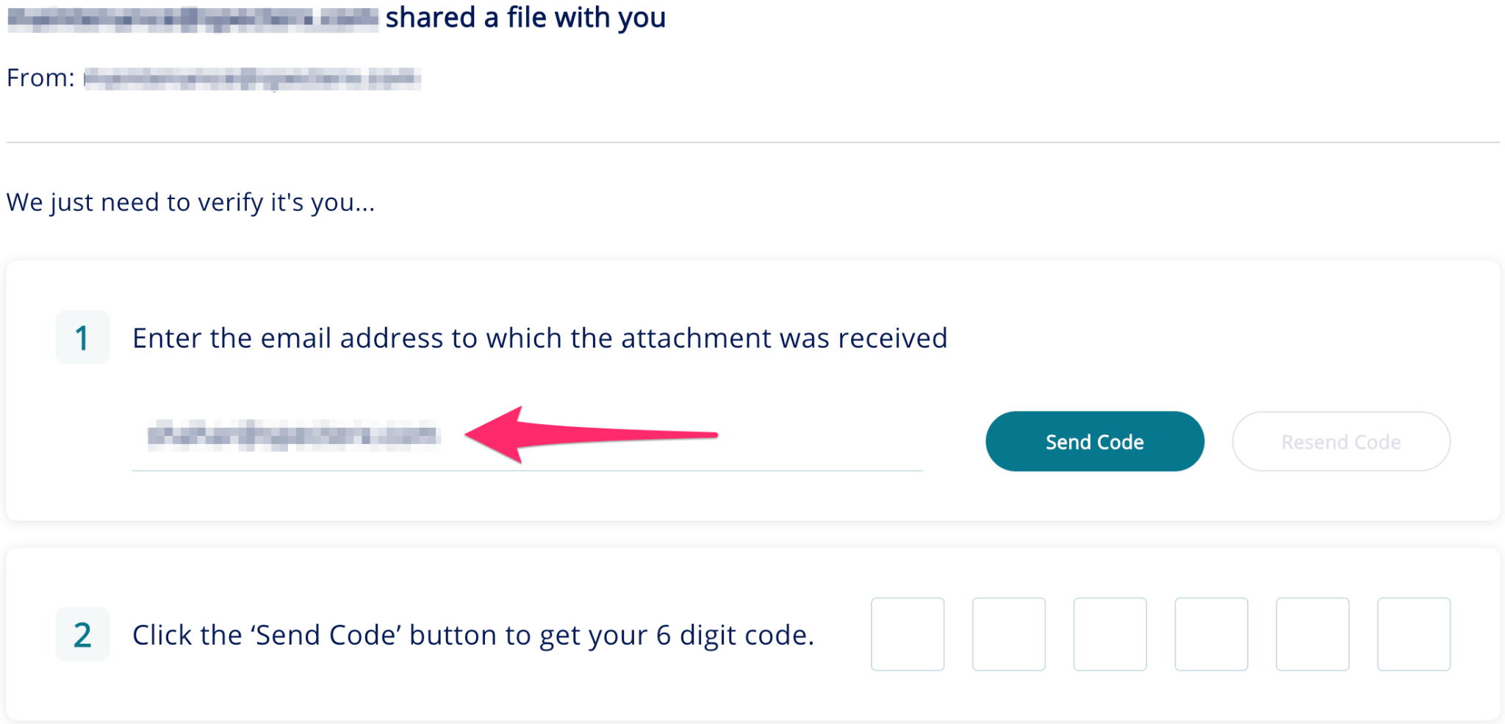
In case of email verification: You will receive an email that looks like this:

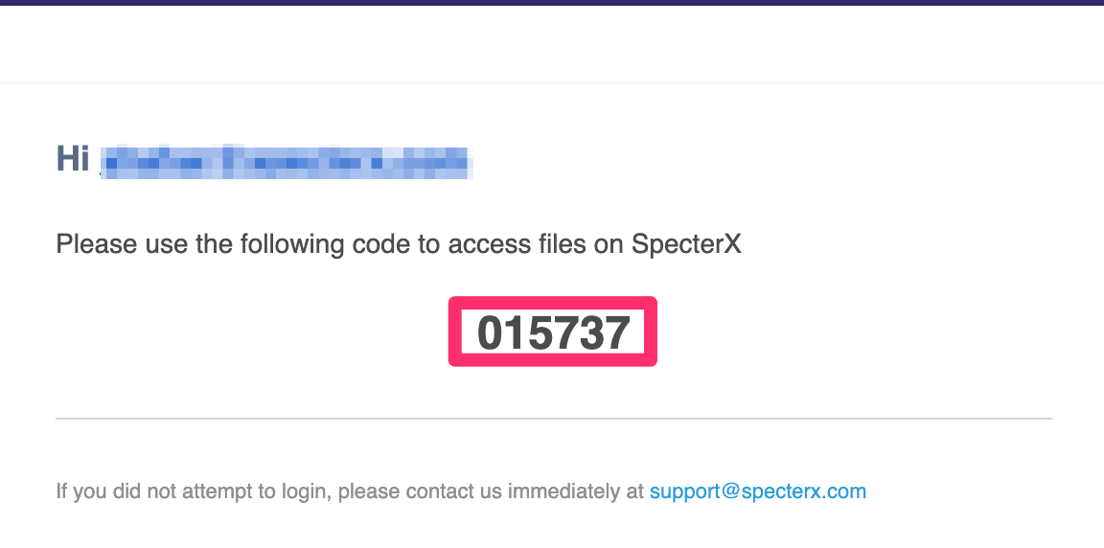

In case of phone verification: You will receive an text message that looks like this:
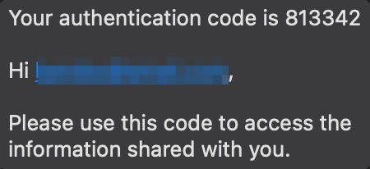

You can either copy-and-paste this code or enter it manually in the authentication screen.

Step 4: Open or Download the shared file
- To open the file - click on the file name
- To download the file click on the ‘Download File Botton’

Step 5: Access SpecterX protected file using native applications
A SpecterX-protected file requires the user to authenticate to SpecterX before gaining access to the file. The authentication requires the user to have a registered account with Microsoft. A Microsoft Account can be either of the following:
- MS Live Account: Commonly associated with personal services such as Outlook, OneDrive, and Skype.
- Office 365 Account: Typically provided by your organization for Microsoft Office subscriptions and related services.

In most cases, you are already signed in with your Microsoft Account. Microsoft uses this account to manage your Office license, which means that if you are logged into Office on your device, you are likely authenticated and ready to access SpecterX-protected files.

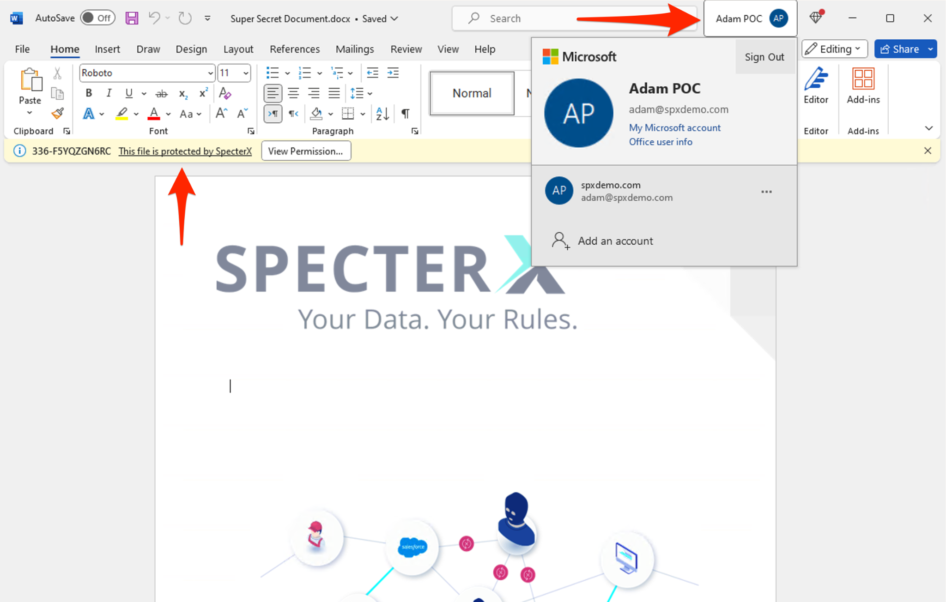

If you are not logged in, you will be prompted to authenticate by entering your credentials for the appropriate Microsoft Account:
- Click on ‘Add Account’
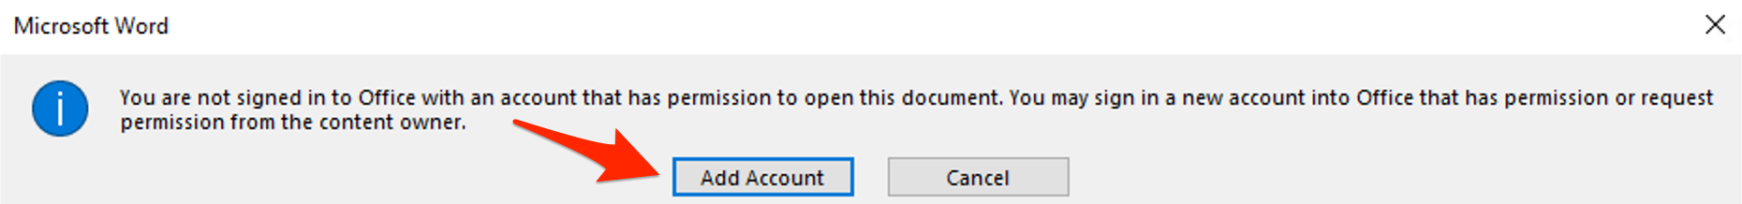

- Sign in using your Microsoft account (Please ensure that you are logging in to Office with the same Microsoft Account to which the file was shared)
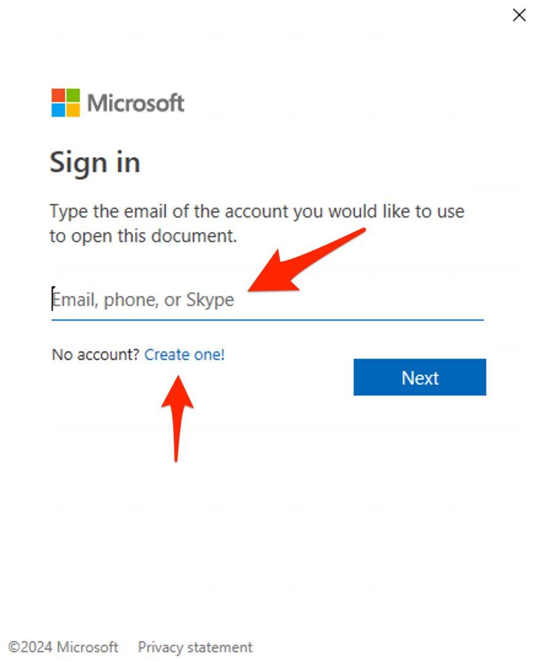

- In case you do not have a Microsoft account, you can click on ‘Create One or click here’ to create a free Microsoft account for your email address.
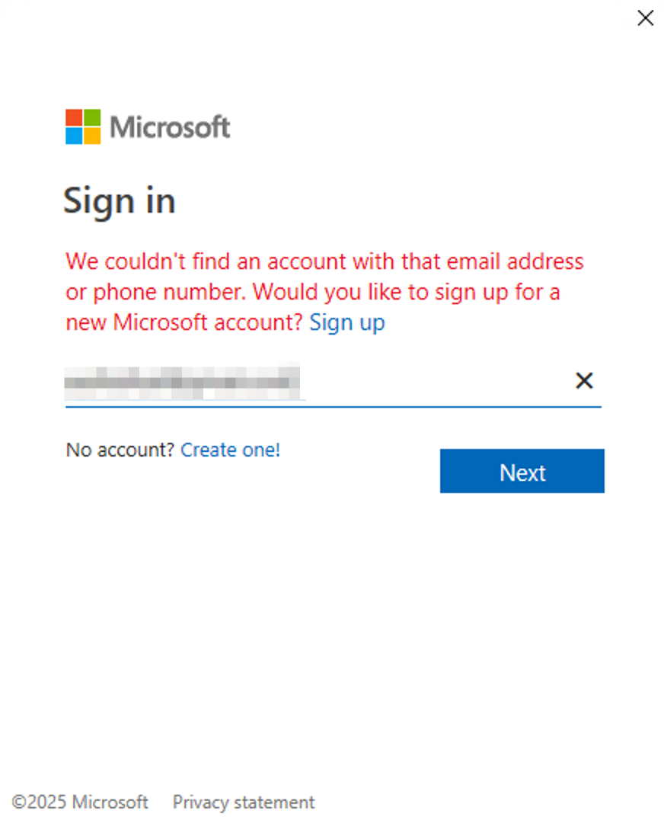

That’s it! You should now have access to the file.
Happy collaborating :)

If at any point you need assistance, our team is always glad to help.
Find us at: support@specterx.com

